**1. What does an empty dictionary's code look like?**

{}

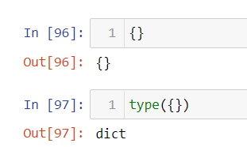

**2. What is the value of a dictionary value with the key 'foo' and the value 42?**

{‘foo’:42}

**3. What is the most significant distinction between a dictionary and a list?**

Dictionary stores data in form of key value pair whereas list shows data in form of values only.

Key value pairs in dictionary are unordered whereas values in lists are ordered values

**4. What happens if you try to access spam['foo'] if spam is {'bar': 100}?**

KeyError error occurs

**5. If a dictionary is stored in spam, what is the difference between the expressions 'cat' in spam and 'cat' in spam.keys()?**

Both are same.

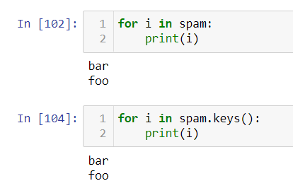

**6. If a dictionary is stored in spam, what is the difference between the expressions 'cat' in spam and 'cat' in spam.values()?**

First one will return the keys of the dictionary spam whereas second case will return only tha values of dictionary spam.

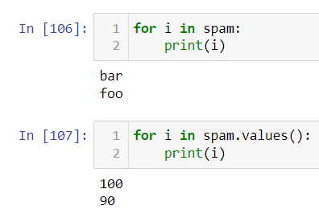

**7. What is a shortcut for the following code?**

**if 'color' not in spam:**

**spam['color'] = 'black'**

spam.setdefault('color', 'black')

**8. How do you "pretty print" dictionary values using which module and function?**

